PRESS RELEASE
FOR IMMEDIATE RELEASE

TL;DR
1) RENT CONTROL / CAP GAP: ~42% vs ~29% low-income rent burden
2) MASSACHUSETTS OUTLIER: ~68% low-income burden — rent control prohibited
3) CRASH RISK: 5 metros at 10/10 (4 in Florida)
4) PRICE DROPS: 76% of Florida homes sell below list price
5) DIVERGENCE: Austin down 23.6% from peak; Chicago up 12.6%

Four Florida Metros Score Perfect Crash Risk; Midwest Markets Stay Safe

"2026 Landlord Exodus & Housing Stress Index" Reveals Extreme Divergence in U.S. Housing Markets
Anaheim, CA — January 2026 — A new analysis finds that a handful of metro areas in Florida and Texas now top the nation’s crash‑risk list while many Midwestern cities remain remarkably resilient. The "2026 Landlord Exodus & Housing Stress Index", published by GigHz, combines Zillow housing and rent indices, state regulatory datasets, and proprietary landlord‑friendliness and affordability metrics to pinpoint where markets are most vulnerable and where opportunities persist. The study shows 32 percent of U.S. metros have declining prices, but the story is much more nuanced: Four Florida metros scored a perfect 10/10 on our crash‑risk scale while Midwest cities such as Rockford, Erie and Utica scored 0/10, indicating minimal risk. Austin, TX sits near the top of the high‑risk list after dropping 23.6 percent from its 2022 peak, whereas Chicago posts new highs and offers the best large‑city yields.
The Index underscores how incentives — eviction timelines, rent caps, permitting delays and tax structures — shape outcomes. Local policy choices interact with migration and employment dynamics to create four distinct capital zones. This year’s update adds a Crash Risk Index and a Safe Markets list, highlighting both extremes. Data for this report are compiled from repit.org, our real‑estate data hub, and used internally by GigHz to guide investment decisions.

KEY FINDINGS
The following highlights capture how varied U.S. housing markets have become:
Price Correction Divergence: - Roughly 32% of U.S. metros still have year‑over‑year price declines, but the extremes tell the story: Austin, once the hottest market, is 23.6% below its 2022 peak (prices down 6.0% YoY) while Chicago is 12.6% above its 2022 peak with prices up 3.6% YoY and rents up 5.9% YoY. States like Florida and Arizona now show negative price momentum, whereas Illinois and New York post gains. - 13 states remain below their June 2022 highs; Florida (-5.4% YoY) and Arizona (-3.2%) lead the declines, while North Dakota (+4.2%), Kentucky (+4.1%) and Wisconsin (+4.1%) head the gainers.
Crash Risk Concentration & Safe Havens: - Our new Crash Risk Index shows that four Florida metros (Punta Gorda, Cape Coral, North Port, Naples, and Sevierville, TN) score a perfect 10/10 on risk, driven by deep price drops, flat or negative rent growth, huge shares of homes sold below list and 60–90 day sale timelines. Austin registers 9/10, reflecting its steep decline and long days on market. - By contrast, Midwest metros like Rockford, IL; Erie, PA; Utica, NY; St. Joseph, MO; Janesville, WI; Canton, OH; Syracuse, NY; and Cleveland, OH score 0/10 on crash risk — they have rising prices, steady rents, fewer than 45% of homes selling below list and single‑digit days to pending. These markets illustrate that not all of America is in a bubble.
Rent Stress & The Landlord Paradox: - Rent burdens are near or above 35% of household income in Miami (37.7%), Los Angeles (34.6%), New York City (38.9%) and San Francisco (26.2%), underscoring acute affordability pressure. Meanwhile, cities like Chicago (26.3%), Dallas (20.6%) and Atlanta (23.0%) remain far more manageable. - A clear paradox emerges: states with strict tenant protections (e.g. California, New York, New Jersey) have average rent stress 2.7 percentage points higher than the most landlord‑friendly states. In other words, heavy regulation correlates with greater rent burden.
Seller Desperation & Market Speed: - Miami (80.2%), Austin (74.3%), Dallas (64.7%) and Phoenix (64.4%) now see a majority of homes selling below list price; days to pending exceed 40–70 days in these markets. Conversely, Chicago (14 days) and Boston (16 days) still close deals quickly, and only ~40–44% of homes sell below list. - Inventory has more than doubled in San Diego (+104%), Dallas (+124%) and Austin (+127%), while supply continues to contract in New York (‑8%) and Chicago (‑6%).
These findings demonstrate that the housing cycle is not uniform: the Sun Belt boom towns are cooling fast, while many Midwest and Northeast cities remain stable or strengthening.

THE LANDLORD FRIENDLINESS DIVIDE
The report introduces a proprietary "Landlord Friendliness Index" rating all 50 states and D.C. on a 1-5 scale based on eviction speed, rent control laws, security deposit limits, and other regulatory factors.
At the ZIP level, the gap is even starker: low-income households in rent-controlled markets spend 42.1% of income on rent versus 29.1% in landlord-friendly states — a 45% higher burden.
Massachusetts presents a unique case: despite banning rent control by ballot initiative in 1994, it has the nation's highest low-income rent burden at 68.4%. This suggests tenant protections beyond rent control — such as slow eviction timelines — may have similar effects.
Key correlation discovered: States with the lowest landlord friendliness scores (California, New York, New Jersey, Massachusetts, Washington, D.C.) average 27.1% rent burden — compared to 22.2% in the most landlord-friendly states.
" Tenant-protective states have the highest rent burdens — the protections aren't solving the problem they were designed to address," the report concludes.

THE FOUR-QUADRANT INVESTOR MODEL
The analysis identifies four distinct "capital zones" driving investment migration:
- Investor Magnet States (24 states): High friendliness + low stress — Kentucky, Alabama, Indiana, Ohio, Kansas, Iowa
- Volatile Opportunity States (18 states): High friendliness + high stress — Florida, Texas, Arizona, Tennessee, Georgia
- Flight States (7 states): Low friendliness + high stress — California, New York, New Jersey, Massachusetts, Washington. Note: "Flight" refers to investor capital, not home prices. Prices remain elevated in these states due to constrained supply and strong owner-occupant demand, but rental investment yields are compressed.
- Stable Low-Growth (1 state): Minnesota
Note: "Flight" describes investor behavior, not price trends. Prices in Flight States often remain elevated due to supply constraints and owner-occupant demand, even as rental investment capital exits.
"The U.S. housing market has split into four capital zones. The migration of landlords is no longer random — it's structural," said Dr. Pouyan Golshani, MD, founder of GigHz Capital and developer of RadReport AI.

VOICES FROM THE CRISIS
These are public comments from online housing forums. Usernames withheld. Lightly edited for clarity.
Massachusetts exodus (people are leaving): > “It was easier to pay rent on $7.25 in 2001 than $22 now. Lifelong MA resident — now in CT.”
Takeaway: The “outlier” states aren’t abstract. People move.
The qualification trap (3× income rules): > “On $2,000 rent, I must make $6K/month to be approved.”
Takeaway: Screening rules can block seniors and low-wage households.
Rent doubled (2019 → 2025): > “In six years my rent DOUBLED. I realized I’d pay less with a mortgage.”
Takeaway: The pressure isn’t just about today’s rent. It’s the trendline.
Small landlord margin (for balance): > “I net ~$250/month per unit after expenses. A remodel takes 8 years to break even.”
Takeaway: Maintenance incentives matter.

ABOUT THE DATA
The report analyzed: - Zillow Home Value Index (ZHVI) for 894 metros and 51 states - Zillow Observed Rent Index (ZORI) for rent trends - Proprietary affordability metrics including income-to-rent ratios and years-to-save calculations - State-by-state regulatory analysis covering eviction laws, rent control, and landlord rights

AVAILABILITY
The full report is available at: https://gighz.com/2026-landlord-exodus/
Press-Kit is available at: https://gighz.com/press-kit/
Methodology is available at: https://repit.org/methods/

MEDIA CONTACT
GigHz Media Relations
Press Team
GigHz.com
Media Intake Form: https://gighz.com/contact/

ABOUT GIGHZ
GigHz is a research and capital platform founded by Dr. Pouyan Golshani,
an interventional radiologist and serial entrepreneur.
Dr. Golshani builds data-driven tools across healthcare and real estate:
- Repit.org — Real estate intelligence platform aggregating ZIP-level
housing, rent, and demographic data for investors and homebuyers
- RadReport AI — Agentic radiology reporting engine
- Nakod.com — AI-powered radiology prior authorization software
- GigHz Capital — Investment advisory for physicians and high-income
professionals
This report was produced using Repit.org data and methodology.

Website: https://gighz.com

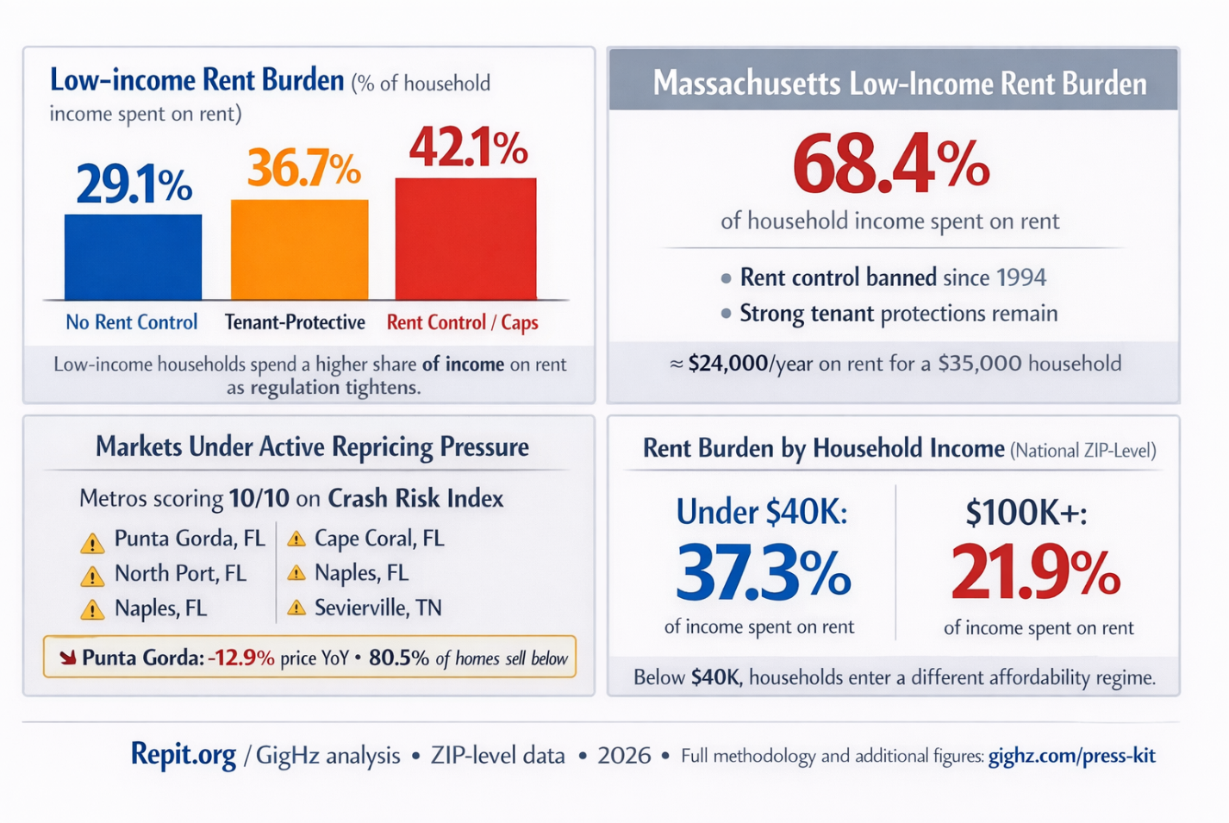

EDITOR'S NOTES

Quotable Statistics (Verified):
- "32% of U.S. metros now have declining home prices year-over-year."
- "13 states remain below their June 2022 peak."
- "Hawaii requires $122,828 household income just to rent the median home."
- "It takes 17.1 years to save for a down payment in Hawaii."
- "76% of Florida homes sell below list price — up 29 percentage points from 2022."
- "Rent growth collapsed from 24% to 1% in Florida since 2021."
- "Housing inventory surged 176% in Colorado since January 2022."

Available for Interview:
Dr. Pouyan Golshani, MD — founder of GigHz Capital, image‑guided minimally invasive surgeon and creator of Repit.org and RadReport AI — is available for interviews on: * The "Rent Cliff" and what it means for landlords * Why investors are fleeing coastal states * The Landlord Friendliness Index methodology * 2026 housing market projections

Suggested Headlines:
- "Report: 32% of U.S. Housing Markets Now in Decline"
- "Study Reveals 'Landlord Exodus' from Coastal States"
- "It Takes 17 Years to Save for a Home in Hawaii, Report Finds"
- "Florida's Housing Correction: 76% of Homes Selling Below List"
- "New Index Ranks States by 'Landlord Friendliness'"

Visual Assets Available:
- State-by-state landlord friendliness map (color-coded)
- Rent cliff deceleration chart (2021-2025)
- Seller desperation index by state
- Years-to-save ranking chart
- Four-quadrant investor model diagram

DATA EMBARGO: None. All statistics verified and available for immediate publication.

