2026 Landlord Exodus & Housing Stress Index

TL;DR
1) RENT CONTROL / CAP GAP: ~42% vs ~29% low-income rent burden
2) MASSACHUSETTS OUTLIER: ~68% low-income burden — rent control prohibited
3) CRASH RISK: 5 metros at 10/10 (4 in Florida + Sevierville, TN)
4) PRICE DROPS: 76% of Florida homes sell below list price
5) DIVERGENCE: Austin down 23.6% from peak; Chicago up 12.6%

Executive Summary
For the first time since the 2008 financial crisis the U.S. housing market is fragmenting into clear winners and losers. Analyzing Zillow home‑value and rent data, state landlord‑tenant statutes, and proprietary affordability metrics, we find that:
- 32% of U.S. metros are in year‑over‑year price decline and 13 states remain below their 2022 peak. Florida, Texas, Arizona and California lead this correction.
- Rent growth has collapsed from double‑digit surges to low single‑digits across much of the country. Florida’s rent growth fell from 23.9 % in 2021 to 1.2 % in 2025; Arizona from 21.0 % to 1.8 %; Utah from 17.7 % to 1.4 %; Hawaii from 21.6 % to 3.2 %.
- Affordability is deteriorating rapidly. Hawaiʻi now requires a median household income of $122,828 just to rent the typical home, and it takes 17.1 years for a median household there to save a 20 % down payment. Thirteen states require more than ten years of saving.
- Seller desperation is spreading. In Florida 76 % of homes sell below list price, 29 percentage points higher than in 2022, and days‑to‑pending have increased by roughly 51 days. Colorado’s for‑sale housing inventory has surged by about 176 % since early 2022, signalling that supply is flooding the market even as demand cools.
- Policy friction matters. States with low landlord‑friendliness ratings—those with slow evictions, rent caps and burdensome deposit rules—also have the highest rent burdens. In California, New York, New Jersey, Massachusetts, Washington and D.C. the median renter spends more than 27 % of income on rent versus 22 % in states with the most landlord‑friendly laws. As economist Milton Friedman taught, “when you tax or regulate something, you inevitably get less of it”; here, restrictive laws have dampened supply and intensified stress.
- Crash risk is highly concentrated. Our Crash Risk Index assigns each metro a 0–10 score based on price declines, rent weakness, seller desperation and days‑to‑pending. Four Florida metros—Punta Gorda, Cape Coral, North Port, Naples and Sevierville, TN—earn a perfect 10/10, signalling deep price declines (up to −12.9 %), rent stagnation or decline, more than 80 % of homes selling below list price and days‑to‑pending well over two months. Austin, TX scores 9/10 after a 23.6 % drop from its 2022 peak and negative rent growth.
- Some markets remain remarkably resilient. The Safest Metros list shows Rockford, IL; Erie, PA; Utica, NY; St. Joseph, MO; Janesville, WI; Canton, OH; Syracuse, NY; Cleveland, OH scoring 0/10—with rising home values, healthy rent growth, moderate seller discounts and fast sales. Midwest markets dominate this list, underlining that not all regions participate in the boom‑bust cycle.
- Tenant‑friendly policies correlate with higher rent stress. Analysis of 50 states and D.C. shows that the six least landlord‑friendly jurisdictions (rating 1) have an average rent stress of 21.0 %, while the most friendly states (rating 5) average 18.3 % rent stress. In other words, states that layer on the most rent caps, eviction delays and deposit limits suffer a 2.7 percentage‑point higher rent burden than the most permissive states.
The full index classifies every state into one of four capital zones based on landlord friendliness and rent stress. Investors are already voting with their dollars—capital is flowing out of the least friendly, most stressed states and into the Southeast, Midwest and Mountain West.

Methodology
This report synthesizes multiple data sources:
- Zillow Home Value Index (ZHVI) and Zillow Observed Rent Index (ZORI) for 894 metropolitan areas and all 50 states. We use the seasonally adjusted, smoothed ZORI series to remove noise and seasonality from rent growth trends.
- State landlord‑tenant statutes, compiled into a Landlord Friendliness Index (1 = least friendly, 5 = most friendly). The index scores eviction speed, rent control laws, deposit caps, late‑fee rules, lease‑termination notices and entry requirements.
- Affordability metrics including income required to rent, years to save for a down payment, and rent‑to‑income ratios. These metrics assume a 20 % down payment and consider housing costs affordable when they consume less than 30 % of gross household income.
- Seller behaviour measures such as the share of homes selling below list price, change in days‑to‑pending, and inventory growth since January 2022.
States are assigned to one of four quadrants—Investor Magnet, Volatile Opportunity, Flight State or Stable Low‑Growth—based on their combination of landlord‑friendliness and rent stress. The index is descriptive rather than normative; as Milton Friedman emphasized, we are measuring incentives and outcomes rather than making moral judgements.

The Landlord Friendliness Divide
The Landlord Friendliness Index reveals a sharp divide between states that encourage housing investment and those that hinder it. States such as Texas, Florida, Alabama and Indiana earn the maximum rating of 5 due to fast eviction timelines, no rent control and flexible deposit rules. At the other end, California, New York, New Jersey, Massachusetts, Washington and D.C. rate 1, reflecting rent caps, “just cause” eviction laws, low deposit limits and lengthy court processes.
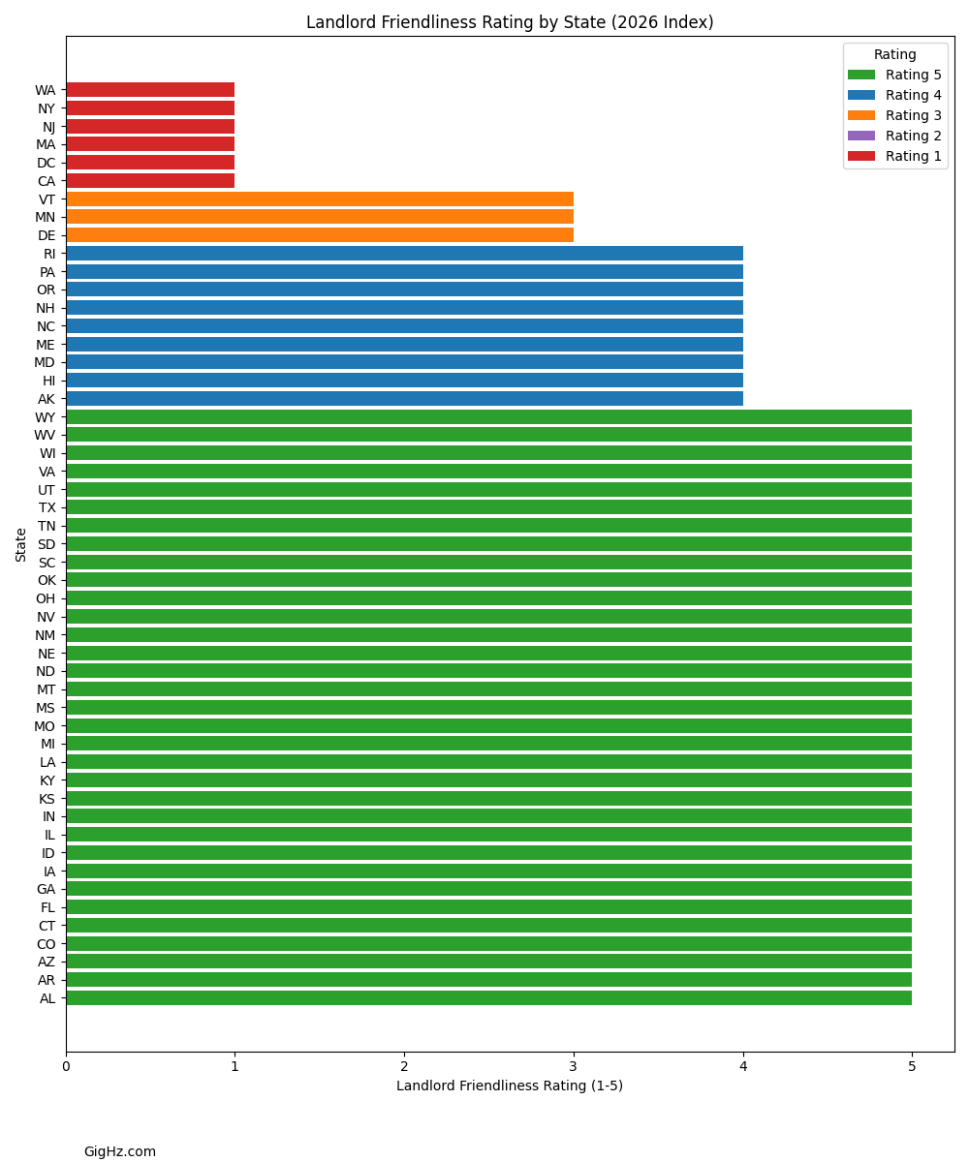
While over half of U.S. states still score 5, investors are increasingly aware of the risk of regulatory drift. For example, Washington enacted statewide rent caps in 2024 and just‑cause eviction rules earlier, pushing it into the lowest tier.

Rent Stress and Affordability
Rent stress—defined as the percentage of household income spent on renting—has emerged as the clearest signal of social and political pressure. The median U.S. renter spends 23 % of household income on rent, but the burden exceeds 30 % in many coastal states. Our scatter plot below compares each state’s landlord friendliness to its median rent burden and colours points by quadrant.
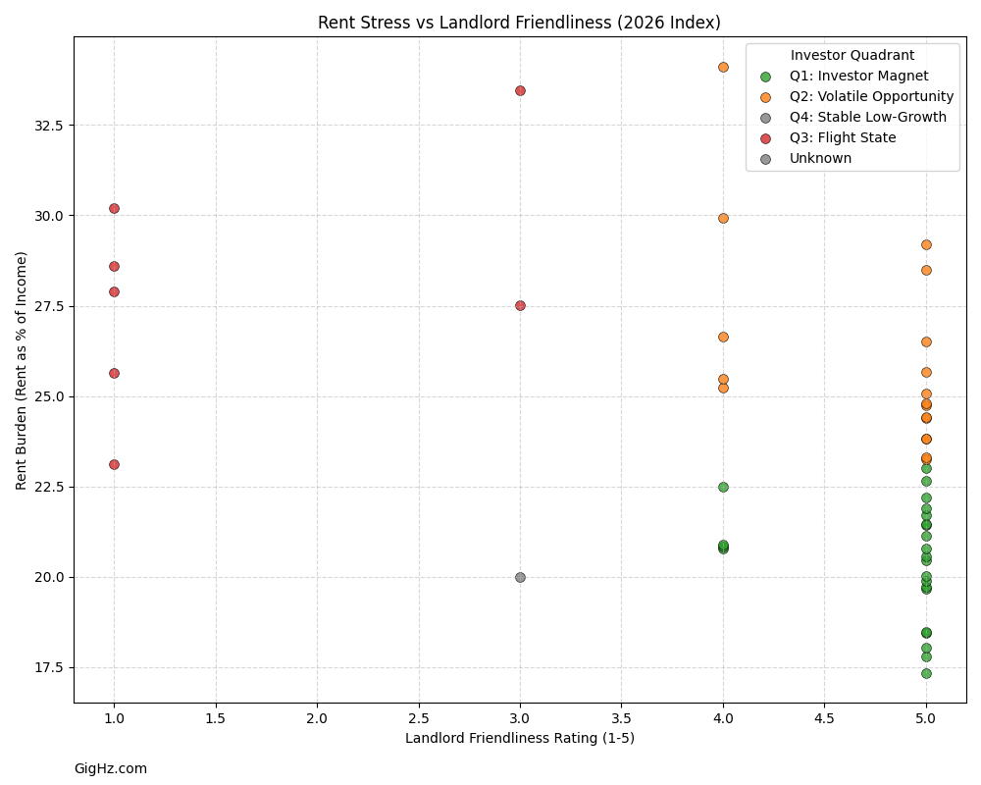
The upper‑left quadrant (low friendliness/high stress) contains California, New York, New Jersey, Massachusetts, Washington and D.C.—the Flight States. Investors rationally avoid jurisdictions where rules are hostile and renters are already stretched; supply stagnates and stress intensifies. As Friedman noted, “markets respond to incentives—capital flows toward states where rules are predictable and away from jurisdictions that penalize investment.”
In contrast, states like Indiana, Iowa, Kansas and Georgia combine high landlord friendliness with moderate rent burdens; these Investor Magnet states attract both residents and capital.
Massachusetts presents a striking outlier: despite banning rent control by ballot initiative in 1994, it has the nation's highest low-income rent burden at 68.4%—suggesting that other tenant protections (slow eviction timelines, deposit limits) may produce similar effects.

The Rent Cliff
After peaking in 2021, rent growth has rapidly decelerated. The bar chart below orders states by their year‑over‑year rent growth (negative values indicate outright declines).
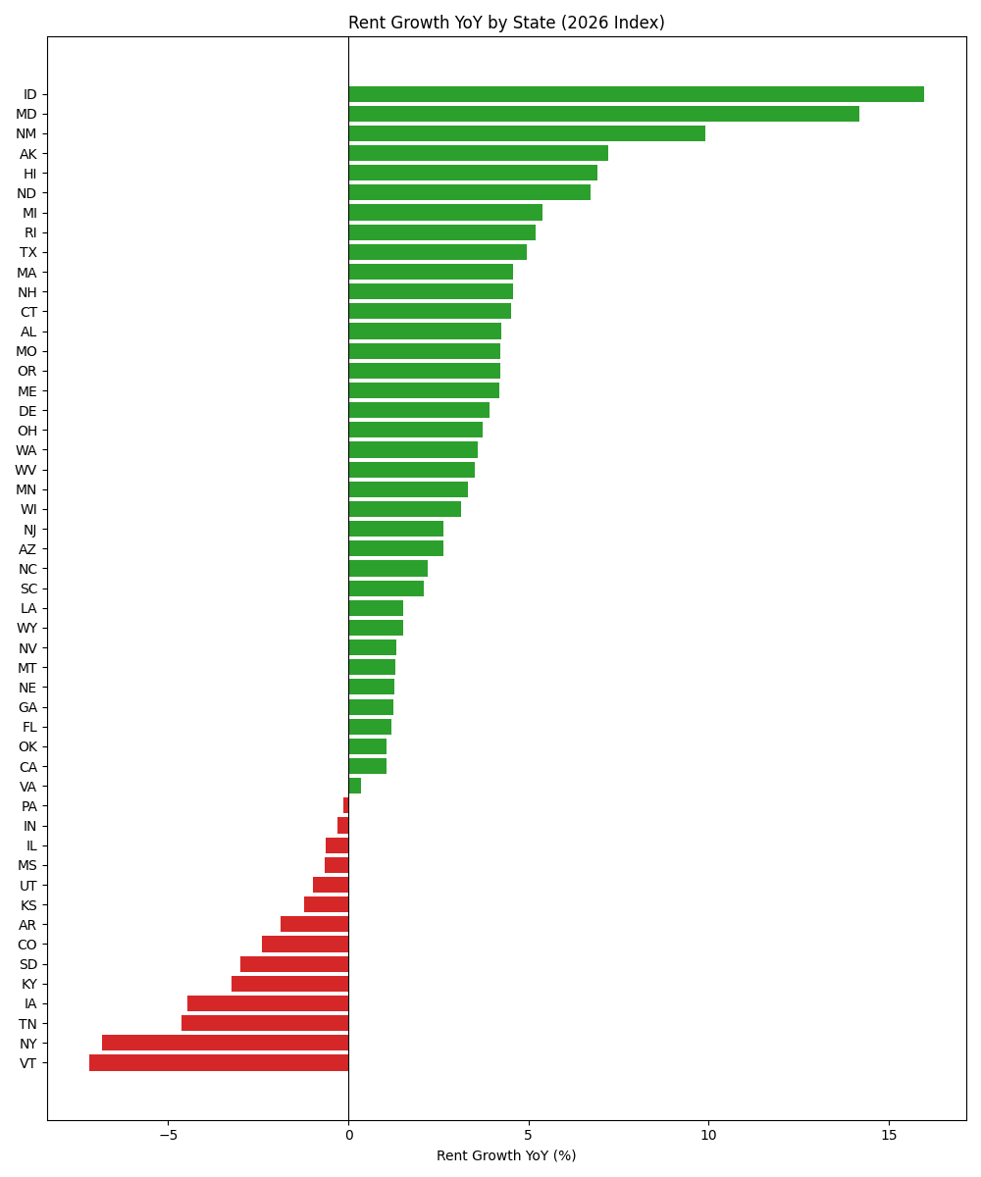
Many states now experience negative or near‑zero rent growth despite still‑tight vacancy rates. The steepest decelerations occurred in states that saw huge surges during the pandemic (Florida, Arizona, Utah) and in heavily regulated markets where supply can’t adjust quickly (California, Washington). This pattern echoes Friedman’s point that supply constraints amplify volatility.

Price Cut Panic
Seller behaviour provides another lens into shifting market conditions. The share of homes selling below list price has exploded in several states, signalling a seller desperation unseen since the Great Financial Crisis.
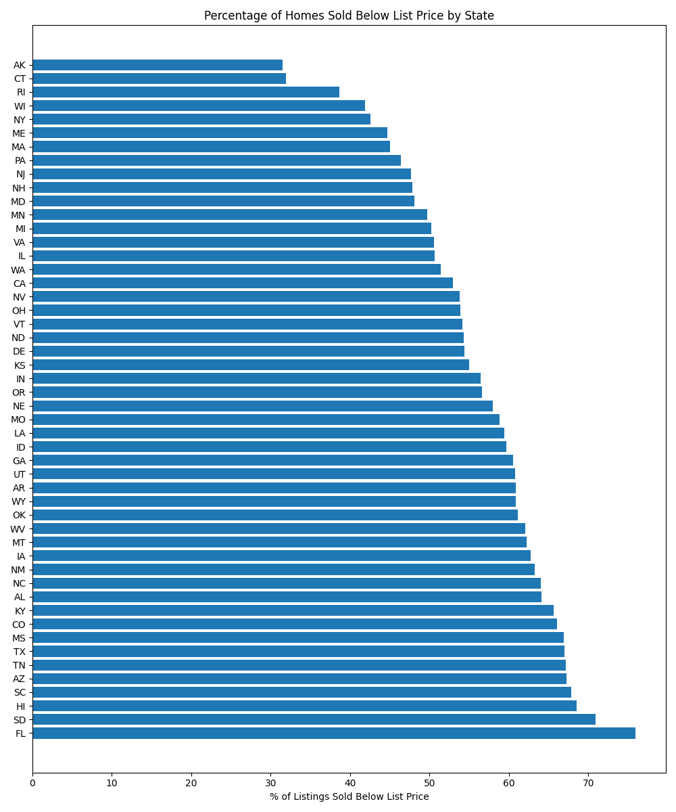
Florida leads with more than 76 % of homes selling below list price, followed by South Dakota and Hawaii. Rising inventories and longer days‑to‑pending in these states suggest that buyers are gaining leverage, particularly in markets with high price volatility and regulatory uncertainty.

Years to Save: The Affordability Collapse
For would‑be homeowners the hurdle is no longer just high prices but time. The chart below ranks states by the number of years a median household must save to accumulate a 20 % down payment (saving 10 % of income and earning no investment return).
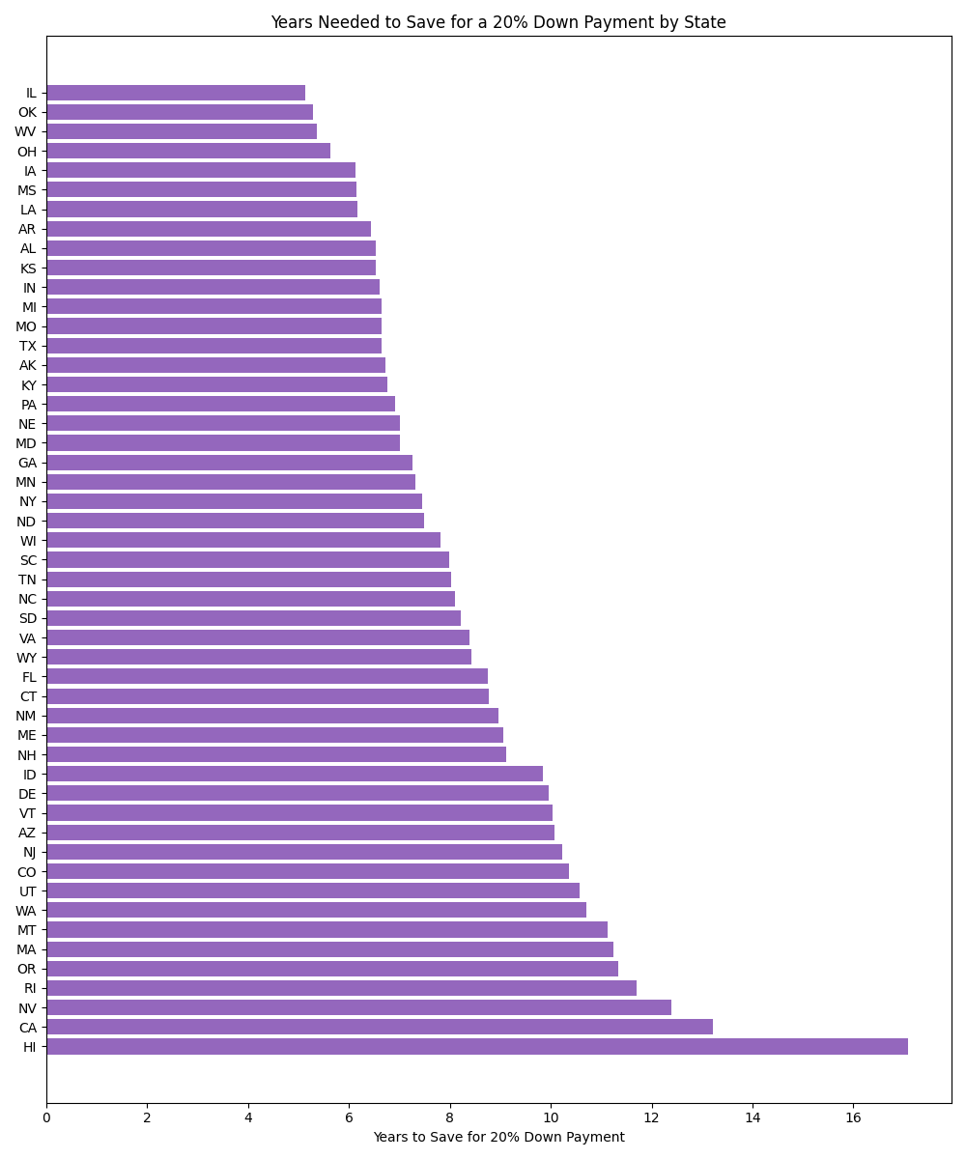
Hawaiʻi tops the list at 17.1 years, with California at 13.2 years and Nevada at 12.4 years. States in the Midwest and South—Mississippi, Oklahoma, Kansas—require fewer than six years. This huge disparity explains why investors and migrants concentrate in interior states: affordability remains within reach and regulations are stable.

The Four‑Quadrant Investor Model
By plotting landlord friendliness against rent stress we identify four distinct capital zones:
Quadrant | Characteristics | Representative States | Implications
Investor Magnet | High friendliness, low rent stress | Indiana, Iowa, Kansas, Alabama, Georgia | Stable cash flow and policy predictability attract both domestic and foreign investors.
Volatile Opportunity | High friendliness, high rent stress | Florida, Texas, Arizona, Tennessee | Strong rent growth and affordability pressure create opportunities but also risk of political backlash.
Flight State | Low friendliness, high rent stress | California, New York, New Jersey, Massachusetts, Washington, D.C. | Investors and landlords exit these markets due to restrictive policies and elevated tenant burden.
Stable Low‑Growth | Low friendliness, low rent stress | Minnesota | Slow price appreciation, stable rents and high regulatory burden limit upside.
Note: "Flight" describes investor behavior, not price trends. Prices in Flight States often remain elevated due to supply constraints and owner-occupant demand, even as rental investment capital exits.
The Investor Magnet and Volatile Opportunity states together account for more than two‑thirds of U.S. housing stock, underscoring why capital is flowing to the Sun Belt and Midwest. As Friedman reminded us, “markets are moved by individuals pursuing their self‑interest”; the four‑quadrant model simply maps where those incentives currently point.

Migration Patterns and 2026 Outlook
Capital does not migrate in isolation; people move with it. Census data show continued outbound flows from the coastal Flight States to the Southeast and Mountain West. We expect this pattern to persist into 2026 because:
- Policy divergence will widen. Pressure from rent‑burdened tenants in low‑friendliness states will lead to more rent caps and just‑cause eviction laws, further discouraging investment.
- Affordability ceilings will constrain demand. High‑income households can no longer sustain price appreciation in California, Hawaiʻi and New York. Even small mortgage rate increases trigger outsized demand destruction.
- Supply expansions will concentrate in friendly states. Builders and landlords respond to incentives; permit issuance is rising fastest in Texas, Florida and the Carolinas.
Investors should therefore prepare for continued softness in overpriced coastal markets and steady cash flow in the South and Midwest. Despite short‑term volatility, markets with transparent rules and manageable rent stress remain the most attractive. This report uses data through late 2025 and early 2026 to project conditions for the coming year.

Metro Snapshots & Top Lists
State‑level analysis exposes broad divergences, but real estate remains intensely local. To ground our conclusions we analyzed 15 major metropolitan areas across the West Coast, South, Mountain West, Midwest and Northeast. Each snapshot below summarizes key metrics—median home value, recent price movements, rent and rent stress, affordability, seller sentiment and market speed. These metros account for a disproportionate share of U.S. housing wealth and investor attention.

West Coast
- Los Angeles–Long Beach–Anaheim: Median home value ~$943k; values remain 4.9 % above their 2022 peak yet rent stress is high at 34.6 % of income. Half of homes sell below list price, days‑to‑pending averages 29 days and inventory has climbed 82 % since early 2022.
- San Diego–Carlsbad: $918k median value (+2.7 % from peak), rent stress 31 %; nearly 55 % of homes sell below list, and inventory is 104 % above January 2022.
- San Francisco–Oakland–Berkeley: $1.10 M median value (10.8 % below peak), rent stress 26.2 %; 44 % of homes sell below list; inventory up 85 %.
- Seattle–Tacoma–Bellevue: $733k median value (3.7 % below peak), rent stress 22.7 %; inventory up 168 %.
- Portland–Vancouver–Hillsboro: $541k median, rent stress 21.1 %; favourable landlord rating (4/5) and relatively high gross rent yield (4.08 %).

South & Mountain West
- Phoenix–Mesa–Chandler: $444k median value (9.7 % below peak), rents declining (−0.4 %), rent stress 22.3 %; strong gross rent yield (4.76 %) and 64 % of homes sell below list.
- Las Vegas–Henderson–Paradise: $430k median value (2.0 % below peak), rent stress 24.9 %; gross rent yield 4.87 %.
- Dallas–Fort Worth–Arlington: $361k median value (5.6 % below peak), rent stress 20.6 %; gross rent yield 5.57 % and inventory up 124 %.
- Austin–Round Rock–Georgetown: $426k median value (23.6 % below peak, worst among major metros), rent stress 18.4 %; 74 % of homes sell below list price and days‑to‑pending averages 72 days (the slowest among the 15 metros).
- Houston–The Woodlands–Sugar Land: $305k median value (1.7 % below peak), gross rent yield 6.48 %; 68 % of homes sell below list.
- Miami–Fort Lauderdale–Pompano Beach: $471k median value (7 % above peak), rent stress 37.7 %—the highest among the 15 metros; 80.2 % of homes sell below list; vacancy rates are elevated.
- Atlanta–Sandy Springs–Alpharetta: $378k median value (+0.2 % from peak), rent stress 23 %; 58.4 % of homes sell below list.

Northeast & Midwest
- New York–Newark–Jersey City: $704k median value (13.3 % above peak), rent stress 38.9 % (highest among major metros); 38 % of homes sell below list and inventory is 8 % lower than January 2022.
- Boston–Cambridge–Newton: $715k median value (10.9 % above peak), rent stress 28.2 %; days‑to‑pending averages just 16 days, the fastest among the metros.
- Chicago–Naperville–Elgin: $337k median value (12.6 % above peak), rent stress 26.3 %; gross rent yield 7.41 % (highest among the metros) and inventory is shrinking.
The bar charts below rank these metros by rent stress, seller desperation (percent of homes sold below list price) and gross rent yield. These visual rankings highlight where renters are most burdened, where sellers are most desperate and where cash‑flow investors might find attractive yields.
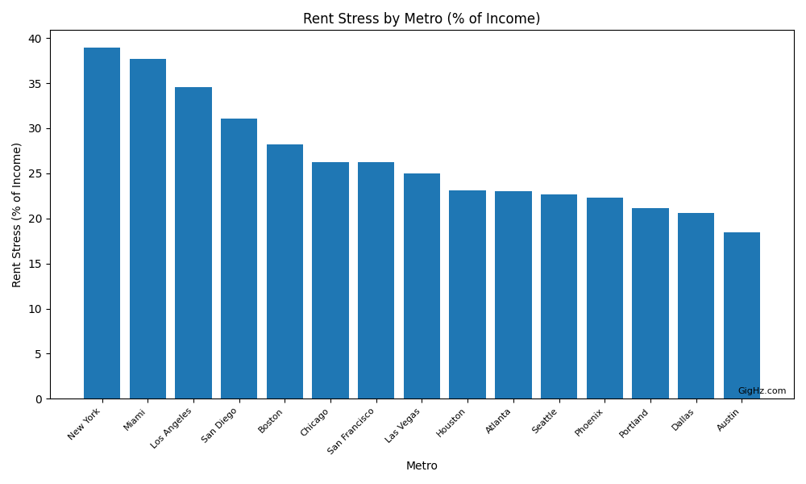
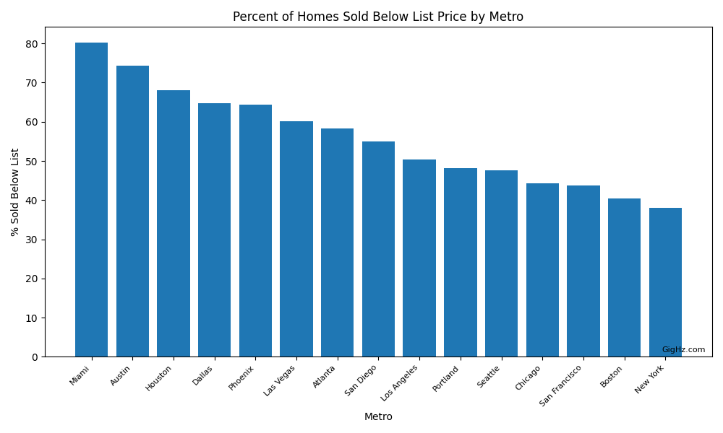
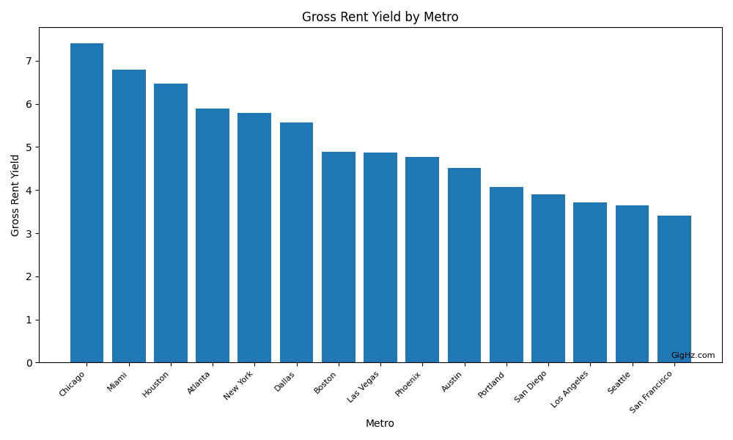

Top 10 Lists
From the full Zillow metro database (894 metros) we compiled a series of Top 10 lists to spotlight extremes. Highlights include:
- Most rent‑stressed cities: New York, Santa Maria, Miami, Kahului and Los Angeles top the list, with renters spending more than 34 % of income on housing.
- Cities where price cuts are surging: Naples, Key West and several Florida markets see more than 80 % of homes selling below list price.
- Worst price declines: Punta Gorda (−12.9 % YoY) and Murray (−12.3 %) lead the nation.
- Furthest below 2022 peak: Austin remains 23.6 % below its pandemic high, followed by Johnstown, Opelousas and Punta Gorda.
- Slowest markets: Key West, Del Rio and Cullowhee all take more than 90 days to go pending.
- Highest crash risk scores: Naples, Punta Gorda, North Port, Cape Coral, and Sevierville score 10/10. Austin scores 9/10; Miami scores 8/10.
Two of these lists are visualized below—showing the most rent‑stressed cities and the metros with the highest crash‑risk scores.
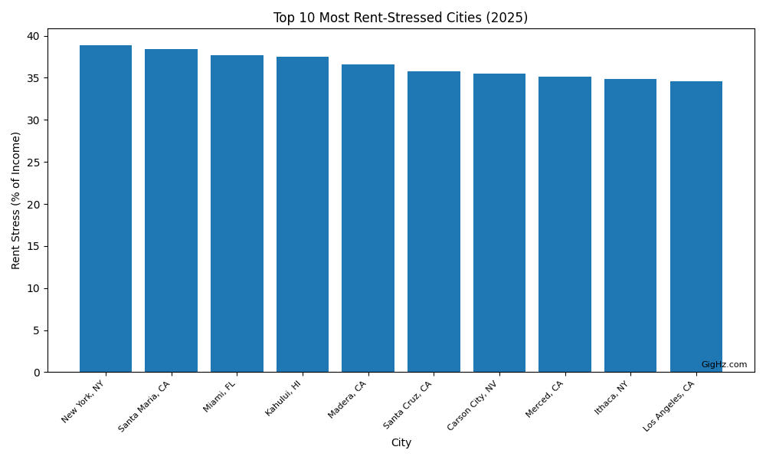
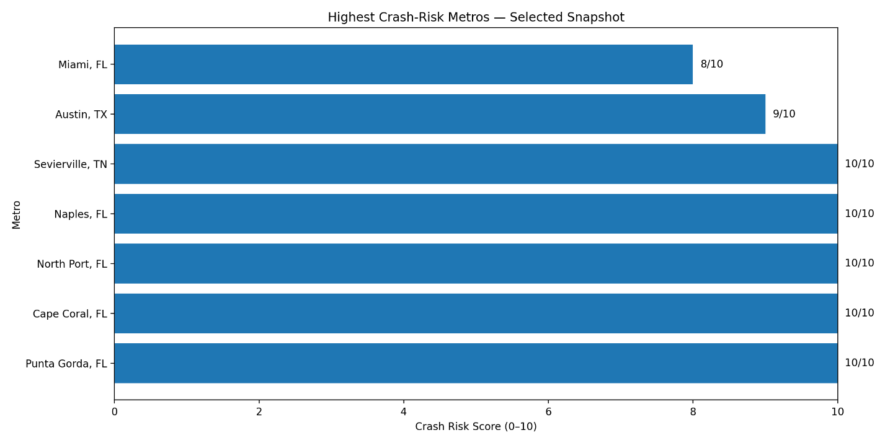

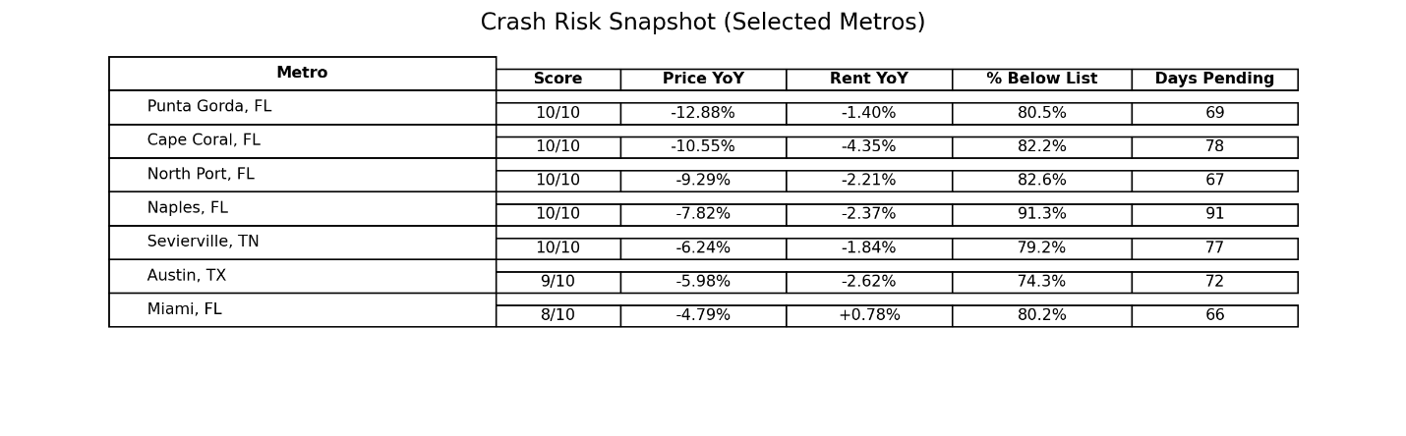
For additional lists—including inventory explosions, price‑cut surges, rent deceleration, best rent yields and the hardest markets to save for a down payment—see the Metro Appendix available on GigHz.com.

Quotes
To frame these findings we turn to the late Milton Friedman, whose work on incentives and free markets remains instructive:
“When you tax or regulate something, you inevitably get less of it.” In housing this means that rent caps, eviction delays and deposit limits constrain supply and raise costs for tenants and landlords alike.
“Markets respond to incentives—capital flows toward states where rules are predictable and away from jurisdictions that penalize investment.” Our four‑quadrant model is a direct observation of that principle.
“I’m not making a moral argument—I’m describing revealed preference.” The exodus of landlords from California, New York and Washington is a consequence of choices made under different regulatory regimes; the data merely record those choices.
As Dr. Pouyan Golshani, MD, founder of GigHz Capital and the creator of RadReport AI, explains: “We’re measuring the incentives embedded in state housing policy. Investors and landlords aren’t villains or heroes; they’re actors responding rationally to regulation, supply and affordability. If policymakers want different outcomes, they need to change the incentive structure.”
“We’re building a national real‑estate data‑farm and API that will spotlight market hotspots across the U.S. and deliver AI‑driven property picks for cash flow or appreciation. It’s updated monthly and informs every real‑estate decision we make.” — Dr. Pouyan Golshani.

Correlation vs causation
Rent control/caps may be adopted in places where rents were already high. This analysis measures outcomes, not intent.
Whether rent control causes higher burden or merely correlates with it, the affordability goal isn’t being achieved for low-income households in these markets — and the gap (42.1% vs 29.1%) exists regardless of causation.
Massachusetts presents a unique case: Despite banning rent control by ballot initiative in 1994, it has the nation's highest low-income rent burden at 68.4%. This suggests tenant protections beyond rent control—such as slow eviction timelines and strict deposit rules—may produce similar affordability outcomes.

Limitations
- ZIP-level averages can hide within-ZIP variation.
- “Policy environment” categories simplify complex local rules.
- Market outcomes are multi-factorial (supply, insurance, migration, income mix).

Conclusion and Next Steps
The 2026 Landlord Exodus & Housing Stress Index demonstrates that the U.S. housing market is splitting into distinct capital zones. States combining landlord‑friendly rules with moderate rent stress continue to attract investment and migrants, while those layering regulation onto already stressed tenants are losing both.
For investors and high‑earning professionals seeking guidance:
- Hands‑off real‑estate investing: GigHz.com sources and underwrites Dallas developments, Tennessee cash‑flow rentals and Southern California entitlement plays, structuring them around your tax needs and risk profile.
- Financial clarity course: Our flagship course helps physicians and professionals budget, invest and live on purpose—without fluff.
- Custom consulting: For founders, family offices and boards we provide med‑tech diligence, graphene market intelligence, AI‐readiness reviews and go‑to‑market planning.
If you would like a personalized analysis of how these trends affect your portfolio or wish to access the ZIP‑level datasets behind this report, contact us at GigHz.com or through our contact form (https://gighz.com/contact/).

AVAILABILITY
The full report is available at: https://gighz.com/2026-landlord-exodus/
Press-Kit is available at: https://gighz.com/press-kit/
Methodology is available at: https://repit.org/methods/

MEDIA CONTACT
GigHz Media Relations
Press Team
GigHz.com
Media Intake Form: https://gighz.com/contact/

ABOUT GIGHZ
GigHz is a research and capital platform founded by Dr. Pouyan Golshani,
an interventional radiologist and serial entrepreneur.
Dr. Golshani builds data-driven tools across healthcare and real estate:
- Repit.org — Real estate intelligence platform aggregating ZIP-level
housing, rent, and demographic data for investors and homebuyers
- RadReport AI — Agentic radiology reporting engine
- Nakod.com — AI-powered radiology prior authorization software
- GigHz Capital — Investment advisory for physicians and high-income
professionals
This report was produced using Repit.org data and methodology.

Website: https://gighz.com

